Scope Overview
ELEVATE 215 | SCOPE DOCUMENT

01 — Scope Decision
Name: Bianca Ruiz | Date: September 21, 2026

1. The problem
Elevate 215’s mission is to improve educational outcomes for students in Philadelphia by increasing the number of high-quality schools, but the information needed to answer those questions is spread across different people and systems. When a funder asks what their money did at a school, staff have to find the grant agreement, ask Renée for the school’s latest performance and visit information, get payment information from Finance, compare everything, and then bring it together before writing the response. Stacy explained, “A funder asks what their money did at a school, and I cannot answer it without three people and a week.” I learned that the information exists, but there is “no one place” where staff can see the grant, school performance, payments, and updates together. This means staff spend time searching, asking, comparing, and verifying information before they can answer an important funder question. My focus is understanding how this information can be easier to find, connect, and review without changing who owns the information or who makes the final decision.

2. What I’m Proposing

Bring grant, school, and payment information together on one dashboard

Less searching and back-and-forth. A week of gathering becomes about ten minutes.

Make school notes easier to find

Give staff faster access to the latest completed information. Renée's visit notes sync in automatically, so no one waits behind her site visits.

Flag missing or outdated information

Earlier visibility into what needs attention. A 3-day auto-pull flags stale data by text and email, and reroutes if the owner is out.

Keep staff in control of what’s happening to the org

Less manual gathering without losing the human touch.

My goal: Create a more connected workflow without changing how staff currently manage their work.

ELEVATE 215 | SCOPE DOCUMENT

02 — Out of Scope

Board Deck
I heard that the board deck creates recurring manual work, but the process is predictable and can be planned for. This can be looked into another time.

Index / School Data
I learned that the public-data refresh can create stale information and takes a few days when new data is released. I’m keeping it as a future area to explore.

Why I’m Focusing on Funder Reporting
I heard that funder reporting creates a significant workflow challenge because staff have to pull information from multiple people and places before they can respond. Stacy said: “I cannot answer it without three people and a week.”

ELEVATE 215 | SCOPE DOCUMENT

03 — Open Questions & Next Steps
What still needs to be confirmed before the scope is finalized

4. What is still open
The question | Who answers it
What does Renée consider a completed/current school note, and how does she update it after a school visit? | Renée
How does Priya confirm that a payment belongs to the correct school, grant, and payment record? | Priya
What exact information does Stacy need to see together before she considers a funder response ready to answer? | Stacy

What I need from them
What | Who provides it | By when
One example of a completed/current school visit note and how it is updated. | Renée | September 28, 2026
One example of the payment information used for a school/grant. | Priya | September 28, 2026
Confirmation of the minimum information Stacy needs before answering a funder. | Stacy | September 28, 2026

Interview & research Summary

Interview Summary
Across both conversations, a consistent pattern emerged: information that should support a single decision is split across people, and no one holds the full picture. Asked to walk through the most recent time a funder asked what their money did, Stacy explained that answering requires pulling from three separate sources Renée's visit notes, the original grant agreement, and payment records in QuickBooks none of which live in the same place. A follow-up question about where the time actually goes surfaced that the bottleneck isn't the work itself: "the actual assembly, once I have the pieces, that's maybe an hour. But start to finish? It's a week." The gap is entirely in coordination and waiting, not effort.
Pressed on ownership who's responsible for pulling it together Stacy was direct that the issue isn't performance: "each of us owns a piece... but none of us own the whole story." That distinction matters, because it locates the problem in the structure of how information is distributed, not in any one person's habits.
The same pattern showed up on the fundraising side. Asked how a pledge moves from commitment to being reflected in the budget, Stacy described a similar split: pledges are tracked in a spreadsheet, separate from the CRM, so the CRM alone never shows what's actually committed. Asked what happens when those numbers disagree, she described a real instance of a $75,000 capacity-building grant approved on the strength of a pledge, where the money landed coded to a different program than intended, requiring a manual reallocation to cover it.
A question about what would happen if she or Yvette were unavailable produced the clearest evidence of how much depends on individual memory rather than any documented system. Stacy described an actual case: Yvette was out for a week, a funder called about a renewal, and a request that would normally take about an hour instead took two days and an emergency phone call — because the context behind that relationship (the funder's shifted priorities, preferred format, real deadline) existed nowhere but in Yvette's head.
Taken together, the interviews point to one underlying pattern rather than several unrelated problems: performance data, financial data, and relationship knowledge are each accurate on their own, but nothing connects them, and the connecting work currently falls to Stacy manually, every time.

Research Summary
What is Elevate 215?
Elevate 215 is a nonprofit organization based in Philadelphia focused on improving education. Its mission is to increase the number of high-quality schools in the city, ensuring that every child has the opportunity to succeed, regardless of their zip code. Elevate 215 doesn't run one program — it operates as a connector and investor across several linked pieces of Philadelphia's education system, all under one operating model: "Convene + Define, Execute + Iterate, Expand + Reinforce" (elevate215.org/our-approach). In practice, that means:
- Schools & talent — invests directly in schools (35 K–8 schools currently, 16,600+ students, targeting 50 schools / 25,000 students by 2027) and runs the Philadelphia Citywide Talent Coalition, where Elevate serves as the backbone organization for 50 partner organizations working on teacher recruitment, pipeline programs, and retention (2025 Impact Report; Talent Coalition results).
- Teacher pipeline programs — includes the Para Pathway Program, which helps paraprofessionals already working in schools become certified teachers.
- Performance-based grantmaking — Beating the Odds identifies schools outperforming expectations and grants them money specifically to scale what's already working, rather than funding blind.
- Family access — Philly Schools Compass helps families navigate school options, and Apply Philly Charter is the actual application system families use for charter school lotteries and seat offers.
So the thread connecting all of it: identify what's working, invest in it, measure it, and help more families access it. Funding is ~93% philanthropic contributions, with named funders William Penn Foundation and The Pew Charitable Trusts (Form 990/ProPublica; funder announcements).
Elevates Mission
When I asked what she cares about most, Stacy said it plainly: "whether we're putting money behind schools that are actually moving the needle for kids. That's it. Everything else is just noise." (interview)
How Elevates success is measured
Publicly, Elevate tracks reach (schools, students) and outcomes (performance, graduation, educator retention) (2025 Impact Report). Internally, she told me she can't yet see that picture across her whole portfolio at once — she can't ask "how are all our literacy grants doing this year" without manually redoing the same assembly work for every single grant (interview). That gap is the whole reason funder reporting takes her a week each time.
Stacy's role
Executive Director since 2021. Publicly, she's accountable for aligning Philadelphia's education community around a shared vision (elevate215.org/team/dr-stacy-holland). In practice, she told me she personally assembles every funder report by hand once she has the pieces — about an hour, once she has all three (E39+E40) — and that there's no documentation for the process "because I'm the process" (E46+E47).
What I knew going in
All public sources: the site, impact report, Form 990 (cross-checked via ProPublica), funder announcements. That gave me scale, funding mix, and leadership — nothing on how work actually moves day to day. The interview filled that in.

Before Workflow
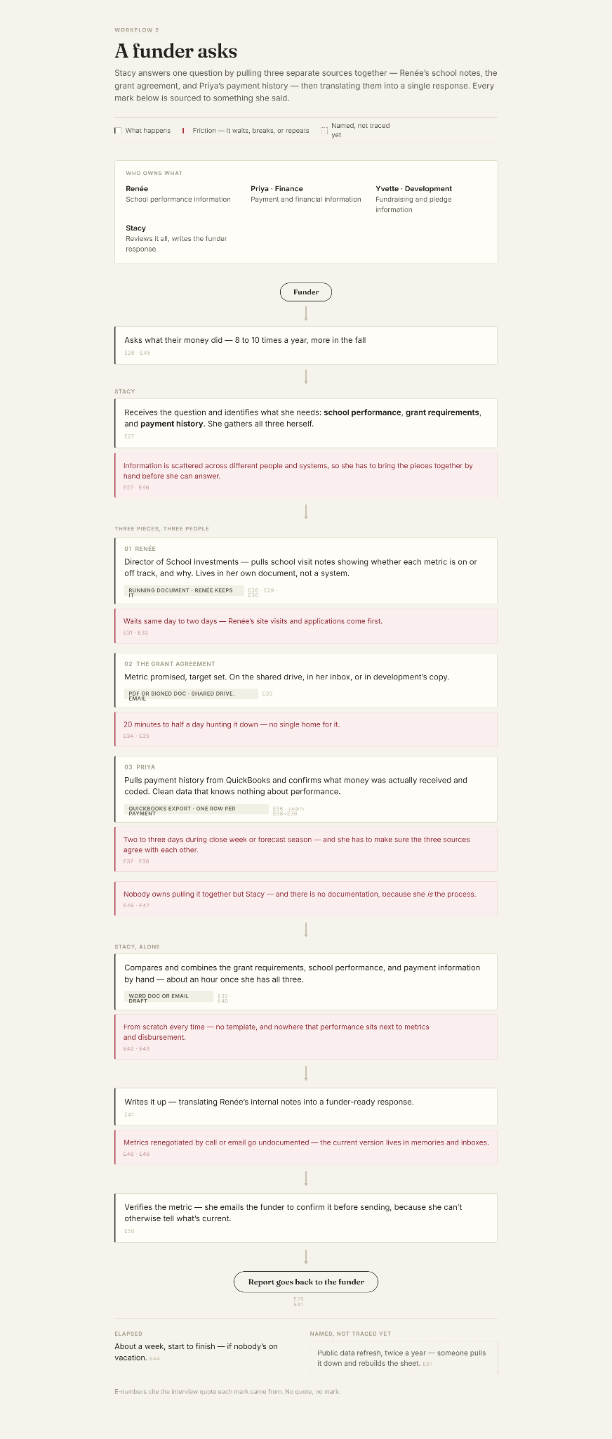

After Workflow
